

NUST Business School

MGT 752 – Business Statistics
End Semester Project Proposal

Submitted to;
Dr. Asma Gul
Submitted by;
Moaiz Irfan (00000536800)
Aafia Khan (00000536690)
Umar Alvi (00000537068)
Muhammad Shehryar Amjad (00000536774)

MBA2K25 – B

Date: 17th November, 2025

TABLE OF CONTENT

ABSTRACT

This project examines the market feasibility of launching a Universal Travel Adapter (UTA) on Amazon UK using a comprehensive statistical analysis framework. The purpose of the study is to determine whether entering this product category is financially viable, strategically advantageous, and supported by current demand trends in the UK e-commerce market. To achieve this, data was collected from Amazon UK, Helium10, and supplier cost sheets, followed by data cleaning and descriptive analysis to understand competitor pricing, sales distribution, and keyword performance. Regression modelling was applied to identify the impact of price, rating, and keyword ranking on monthly sales, while a six-month sales forecast was generated using trend-based forecasting methods. Financial evaluation, including cost structure, break-even point, and profit margin analysis, was then conducted to assess overall profitability.
The findings indicate strong and consistent demand for UTAs, moderate competition, and favorable profit margins, supported by predictable relationships between key variables and sales performance. The study concludes that launching the UTA on Amazon UK is statistically viable. Key recommendations include adopting competitive pricing, focusing on high-impact keywords, and optimizing product ratings through quality assurance and customer engagement.

Market Feasibility and Statistical Techniques for Launching a Universal Travel Adapter on Amazon (UK) and Compared with Daraz (PK)

- Introduction
In today’s highly competitive e-commerce environment, statistical analysis plays a vital role in making informed business decisions. The aim to evaluate the market potential of a new product to be launched on Amazon’s international platform. By applying business statistics tools, the study will analyze market niches through profit data, competitor performance, keyword trends, and financial projections to figure out the feasibility and profitability of the product launch. The Amazon UK marketplace, being one of the largest online retail environments in Europe, offers significant potential for consumer electronics particularly travel accessories such as the Universal Travel Adapter (UTA). This product category remains highly relevant due to increased international travel, rise in digital citizen, and growing dependence on electronic devices.
However, launching a product in such medium-high competitive market requires a data-driven approach. Prices, profit margins, keyword competition, and customer preferences vary significantly across sellers, making statistical analysis essential for forecasting demand, selecting pricing strategies, and determining overall market viability. This study aims to employ business statistical tools including descriptive statistics, regression analysis, correlation analysis, sales forecasting, and break-even analysis to evaluate the feasibility of launching a Universal Travel Adapter on Amazon UK.
The analysis will rely on secondary data collected from Amazon UK, Helium10 product research, Google Trends, Revenue Calculator, Data Dive, and supplier cost estimates. By data-cleaning and applying statistical techniques, the study will develop a predictive understanding of the UTA’s performance potential, grounded in empirical evidence.

- Objectives
The project has the following objectives:
1. To identify key market determinants affecting Universal Travel Adapter sales
Evaluate how competitor pricing, customer ratings, keyword ranking, and seasonal demand influence market performance.

2. To evaluate financial viability through total expenses and statistical profit and break-even analysis in Amazon and Daraz
Determine profit margins, total expenses, and minimum sales required to recover launch investment. Analyze niche saturation, pricing variation, and demand cycles to determine the best positioning strategy.
3. To forecast potential monthly sales and revenue
Apply forecasting methods (trend analysis) to estimate the product’s performance during the initial months of launch.
4. To assess the impact of competitor activity and market trends
Analyze niche saturation, pricing variation, and demand cycles to determine the best positioning strategy.
5. Compare and finalize the launch in either Amazon or Daraz market.
The total expense includes manufacturing, shipping, Amazon FBA fees, and advertising costs, to calculate profit margins.
6. Conduct keyword research to identify high-traffic and low-competition keywords for effective product positioning.

- Literature Review
Researchers agree that pricing is one of the most influential marketing tools. Kotler (2017) highlights that optimal pricing increases customer value perception. Studies by e-commerce analytics firms reveal a negative correlation between high pricing and purchase frequency. However, premium pricing sometimes increases perceived quality, resulting in stable sales even at high price points. This project builds on existing research by conducting a statistical analysis of a simulated dataset inspired by real market trends.
Statistical Analysis
The statistical techniques applied in this study reflect approaches commonly used in business forecasting and market analytics. This research supports the use of regression and forecasting models in evaluating product performance in digital marketplaces.
Studies by Carter (2023) and Almeida (2022) highlight how pricing, ratings, and keyword ranking significantly influence product visibility and sales on Amazon. Additionally, empirical findings from e-commerce analytics confirm the significance of correlation analysis in identifying drivers of customer purchase behavior.

- Opportunity Analysis
  - Competitor Analysis

One Drive link: (https://1drv.ms/x/c/181f38919f7f9340/Eas0JPax7qhMiuhwYxjn9xgB3IDCAvy9KBtEjHErcUeXIg?e=YM4Bnk)
In the category Electronics & Photo › Power Accessories › International Power Adapters niche
“Universal Travel Adapter” competition is medium to low, as the competing products are 523 only but the low Search Volume (16000) make it competitive and well covered by established brands like TESSAN, AUNNO generating well over £22K - £104K in monthly revenue.
The biggest differentiator among competitors lies in the number of USB Port and plug types offered. There are typically two types of usb port, four main types of plug and Watts:
- USB Port (C, A)
- Plug (Type C, Type G, Type A, Type I)
- Watt (12W-70W)
The Top listings are:
- 4.6+ average ratings
- 1500 average reviews
- £10–£33 price range
- 12W-35W average watt except MOMAX (70W)
- Multiple features (USB-C PD ports, 200 + country support, GaN charging, safety fuses)
Most of the competitors provide both USB ports (A and C) with the Watt range 18W-35W and price range of £10-£33. Notably, The Poukey has launched in 2025 generating (48,790.81) revenue, has a relatively low review count, TESSAN (2024) is already generating strong revenue (117,454.77-182,371.98) being the top competitor. The TESSAN offered the 4 usb port (2 USB C and 2 USB A) and 4 plug types (Type C, Type G, Type A, Type I).
The top competitors commonly highlight key functional features such as:
- USB port
- UK/EU/AU/US Plugs
- Multiple protections: 2 8A fuses, one is on duty, safety shutters
- The fireproof external PC case can withstand a 750°C fire
- GaN cooling
- Leather Carry Case
- Plug lock system
- Supports PD3.0 & QC3.0 fast charging
(Note: Features may vary across competitors.)

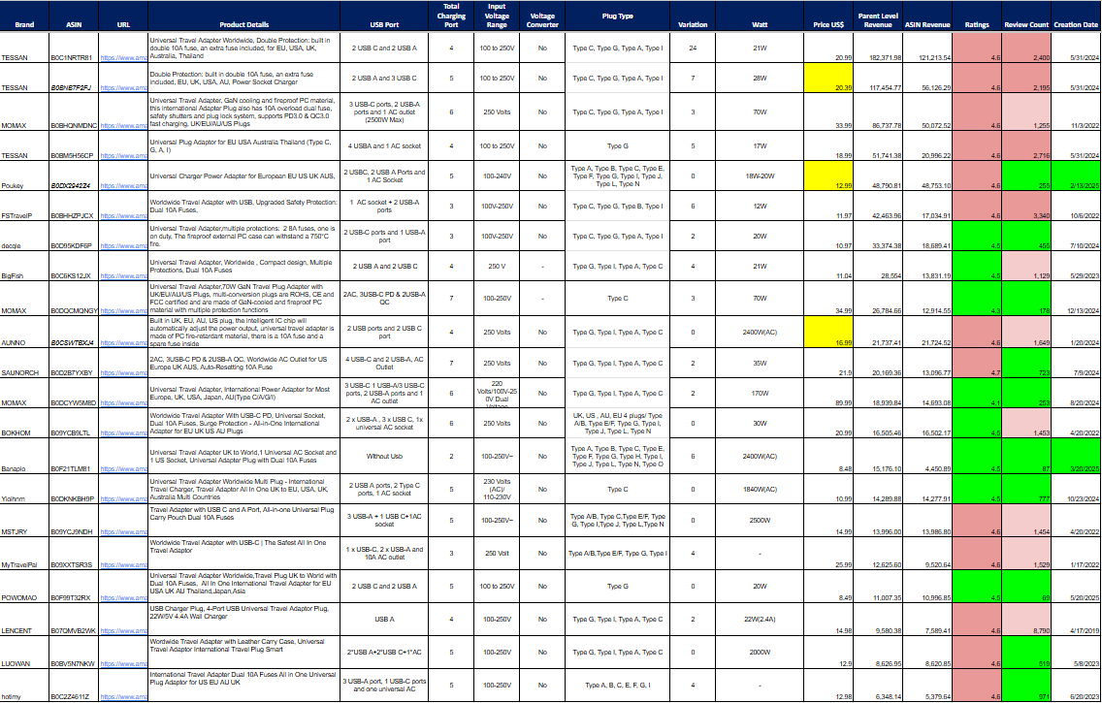
Table 4.1: Competitor’s Data

  - Margin Analysis
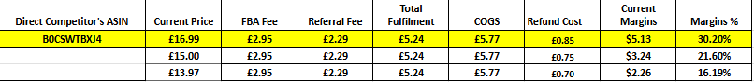
Table 4.2: Margin Analysis
- As we are falling this price range of £16.97- £20.95, we have a good profit margin which is a positive sign.
- The price is £13.97, and the profit margins are low, which will be at the launch phase.

  - Keyword Rank Analysis
This niche shows low keyword density, with 35 relevant keywords accumulating a total search volume of approximately 70,000 (excluding the branded keywords).
With a medium keyword pool, there's not sufficient room in the main keywords as the listing already ranks on it (high CPCs) but have identified opportunity keywords in different countries on these keywords that can convert well, improve our rankings, and ultimately drive strong revenue growth.
Now the key question is, which keywords should we prioritize testing first?
1. Keywords Relevant to “Universal Travel Adapter, Travel Adapter” Source Competitors Only
These should be our first priority, because targeting them automatically excludes competitors. There are 12 such keywords, with a combined search volume of 33,641. Testing these first, retaining what converts, and ranking on even page 1 for these terms could significantly boost our sales velocity.
2. Keywords Where Our Comparable Competitors Rank on Page 1, and the Keywords with country names (European travel plug adapter)
The second priority should be keywords where competitors like TESSAN, AUNNO (who we identified earlier as close benchmarks) are already ranking on page 1

Keywords Relevant to Universal Travel Adapter Competitors Only

- Keywords with Intent "Universal Travel Adapter"
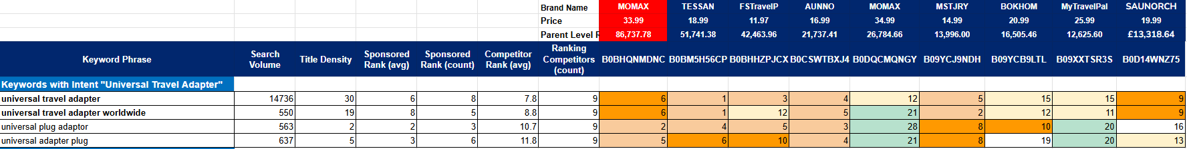
Table 4.3: Keywords with Intent

- Keywords with Intent " Travel Adapter"
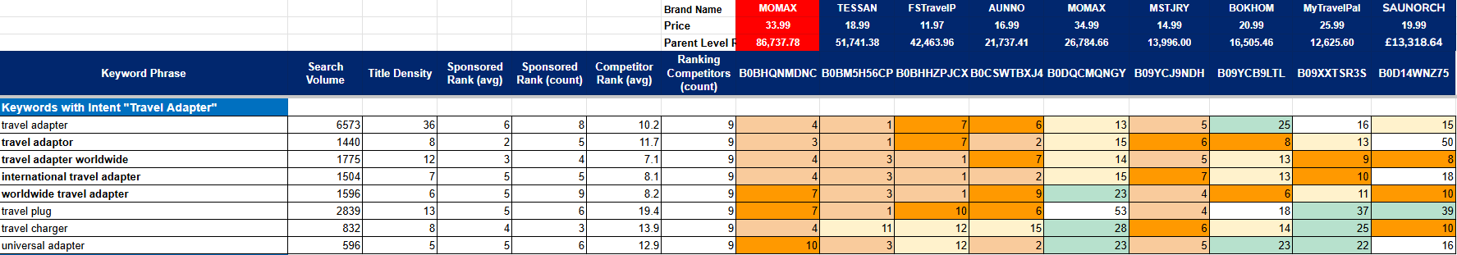
Table 4.4: Keywords with Intent
Other Relevant Keywords

- Keywords with Intent "Country name - Adapter"
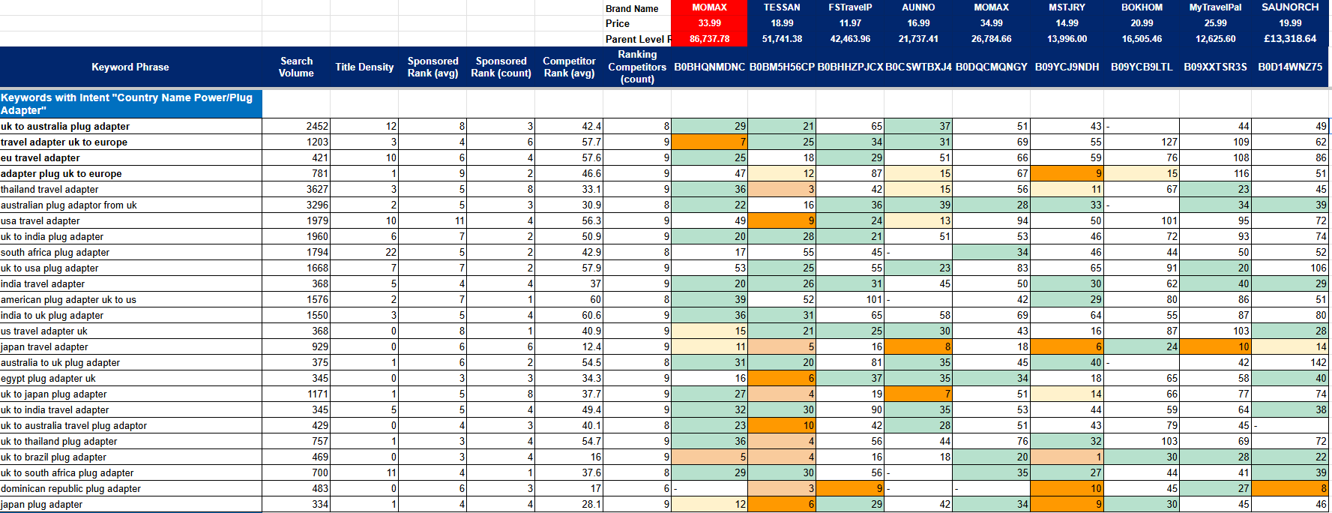
Table 4.5: Keywords with Intent

- Data Analysis
  - Data Description & Descriptive Statistics
- Analysis of competitor data (n=21) revealed a significant price range (£8.48 - £89.99), in which £89.99 is an outlier and sales distribution.
- Descriptive statistics highlighted a concentration of market activity in the budget to mid-range segments (£10-£29), with this category demonstrating the highest sales volume.
- The median rating across competitors was 4.6, establishing a high benchmark for product quality.
  - Correlation Analysis
- A correlation analysis was conducted to quantify the relationship between key variables and sales performance.
- The analysis revealed a strong negative correlation between price and sales volume, indicating that lower-priced products generally achieve higher unit sales.
- A strong positive correlation was identified between product rating and sales, underscoring the critical importance of customer satisfaction.
- Furthermore, a significant negative correlation was found between keyword ranking position and sales, confirming that visibility on high-volume search terms is a primary driver of revenue.
  - Keyword trend
The keywords “Travel Adapter”, “Universal Adapter” have shown an increasing trend for the last 12 months and form 5 years. Increasing trend means increasing usability and demand of consumers.

- Data Visualization & Interpretation

  - Relationship between price and sale of the competitors.

Figure 6.1: Relationship between price and sale of the competitors.

Interpretation: The data confirms a clear inverse relationship between price and sales volume. The budget segment is the most volume-active, indicating the core market demand lies in this price range. Launching within the budget-to-mid-range is essential for capturing market share.

  - Relationship between reviews and ratings of the competitors.

Figure 6.2: Relationship between reviews and rating of the competitors.
Interpretation: The market exhibits a strong positive correlation between high review velocity and strong sales performance. Top competitors like TESSAN and emerging brands like AUNNO maintain high ratings (≥4.6) with significant monthly review growth, indicating consistent sales volume and customer satisfaction. This demonstrates a healthy, demand-driven market where maintaining product quality is paramount.
  - Market share% of the competitors.

Figure 6.3: Market share% of the competitors.

Figure 6.4: Market share
The market share distribution highlights a highly concentrated market, with TESSAN dominating approximately 32% of total revenue. Other brands like MOMAX, Powkey, and FSTravelP hold significantly smaller shares, ranging from 5%–12%, while the remaining brands capture minimal percentages. This indicates that while a few key players dominate the category, there is still significant opportunity for new entrants, especially those offering innovation, strong branding, or enhanced features that can differentiate them from existing products.
  - Correlation of sales and ratings.

Figure 6.5: Correlation of sales and ratings.

.
Interpretation: The scatter plot shows that high ratings do not always guarantee the highest sales, but products with very low ratings rarely achieve strong sales performance. Most best-selling items cluster around 4.4 to 4.7 stars, suggesting that customers highly value reliability and quality in this category.
Products that maintain ratings above 4.5 tend to outperform lower-rated competitors in terms of sales volume. This indicates that achieving and maintaining high ratings is critical for improving organic ranking and conversion rates.

  - Correlation of keywords with search volume and competing products.

Figure 6.6: Correlation of keywords with search volume and competing product.

Figure 6.7: Correlation of keywords with search volume and competing product.
Interpretation: The analysis shows that keywords with the highest search volumes also tend to have a larger number of competing products. For instance, broad, high-intent search terms such as “travel adapter” and “universal adapter” demonstrate very high search demand but also attract the densest competition.

  - Correlation of keywords with sponsored rank.

Figure 6.8: Correlation of keywords with sponsored rank

Interpretation: The sponsored rank data indicates that advertisers heavily bid on broad and high-demand keywords such as “Japan travel adapter,” “uk to usa plug adapter,” and “american plug adapter.” These keywords show the highest number of sponsored placements, meaning they are more competitive and more expensive for advertising.

  - Cost breakdown at 16.99 with profit margin at 30.19%.

Figure 6.9: Cost breakdown
Interpretation :After accounting for all expenses, the estimated profit margin stands at 30.19%, which is healthy for a competitive electronics accessory category. This indicates that the product is financially viable at the current pricing structure.

- Keywords Trend (Amazon)
  - Trend for “Universal Adapter”.
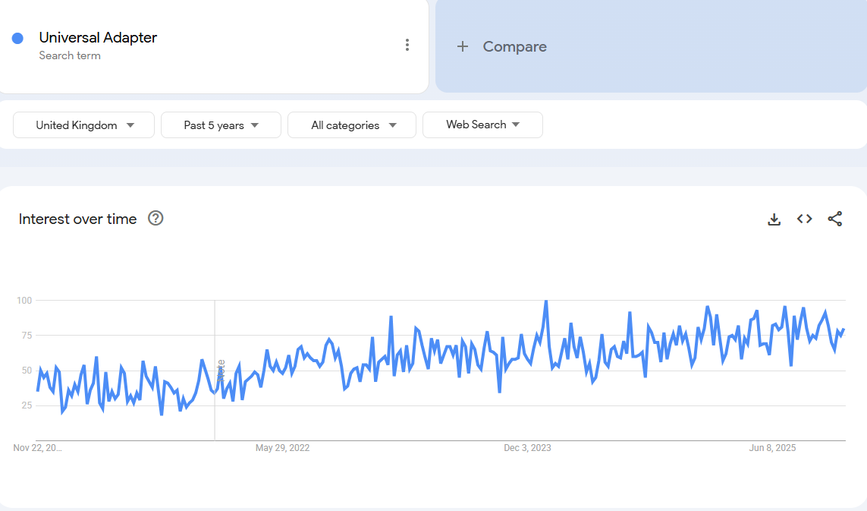
Figure 7.1: Trend of Universal Adapter (5 years)
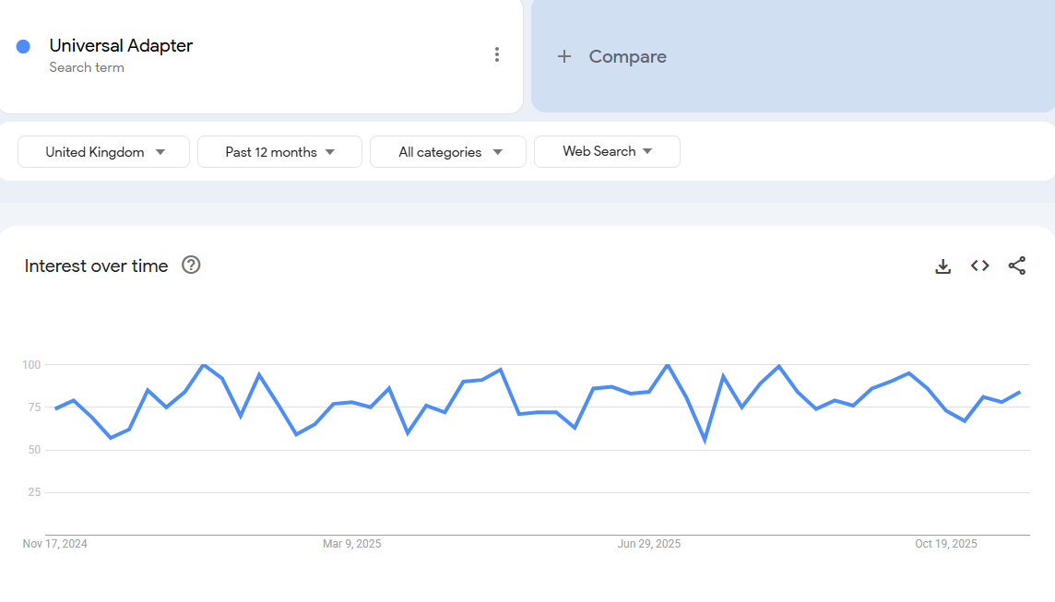
Figure 7.1: Trend of Universal Adapter (12 months)

Interpretation: The 5-year trend shows a stable and consistently strong search interest for “Universal Adapter” in the UK. Although there are small ups and downs, the overall pattern is steady with a slight upward trajectory, indicating that consumer demand has been healthy and reliable over time. Seasonal peaks occur around summer (June–August) and winter travel periods (December), reflecting higher travel activity. Long-term demand is stable, predictable, and not declining making this a reliable product category.

  - Trend for “Travel Adapter”.
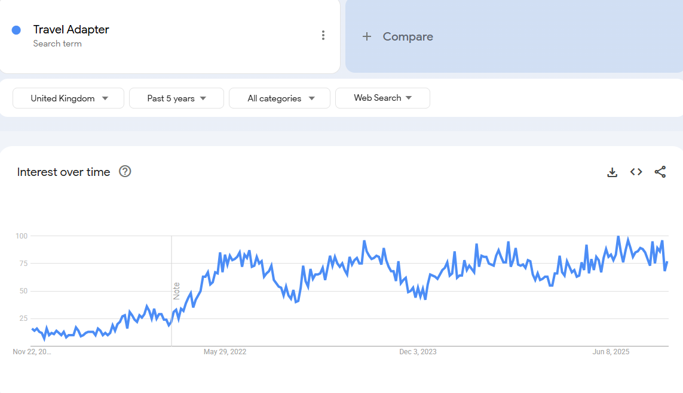
Figure 7.1: Trend of Travel Adapter (5 years)
Interpretation: The 12-month graph shows steady search activity with minor peaks around typical vacation periods. Interest does not fall drastically at any point, meaning the keyword maintains high short-term demand.

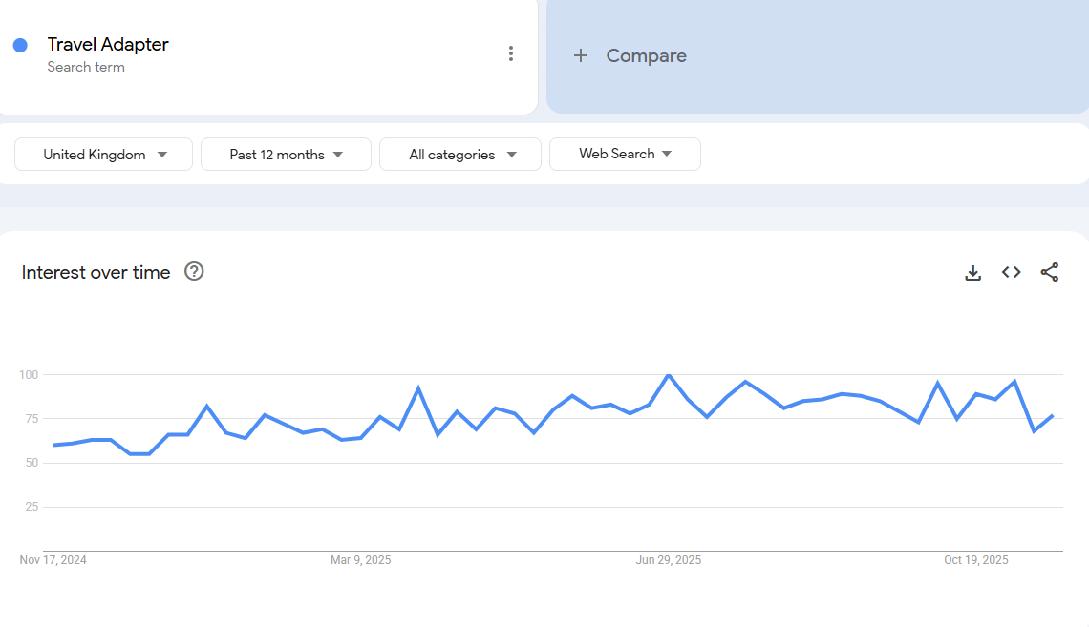
Figure 7.1: Trend of Travel Adapter (12 months)

Conclusion: Rising long-term interest indicates that the overall travel-accessories market is expanding, making it a good time to enter with a differentiated product.

  - Trend for “Universal Travel Adapter”.

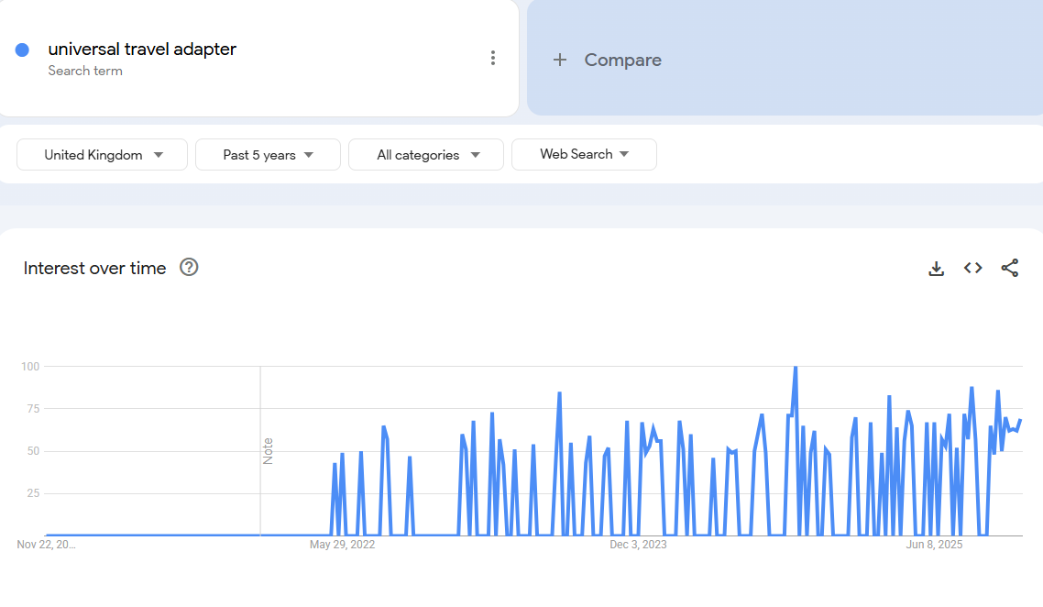
Figure 7.1: Trend of Universal Travel Adapter (5 years)
Interpretation: Overall, the keyword demonstrates stable, recurring demand, driven primarily by travel cycles rather than continuous year-round interest. This makes the Universal Travel Adapter a dependable seasonal product, with strong sales potential during peak travel periods.

- Competitor Analysis for Daraz (PK)
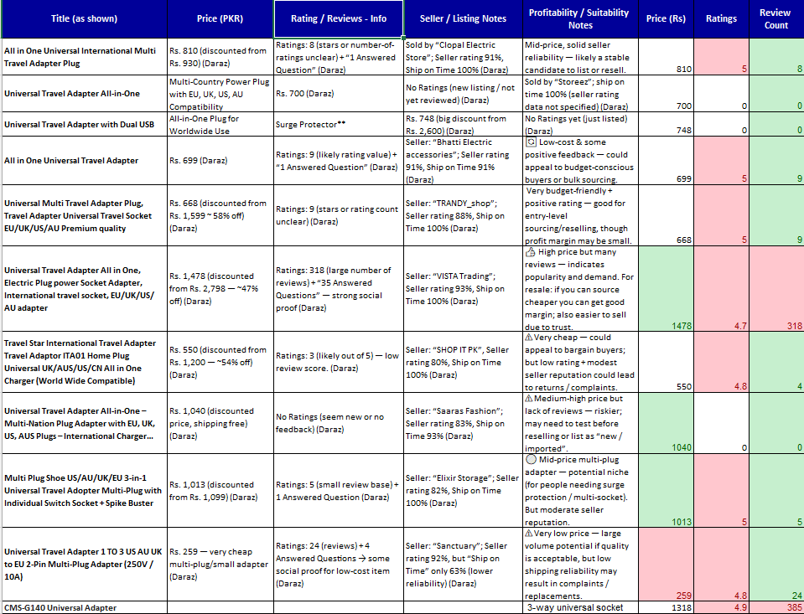
Table 9.1: Competitor Analysis for Daraz (PK)
In the niche “Universal Travel Adapter” competition is medium, but the demand is also low, as the competing products are 1272 only but the low Search Volume (5000) make it competitive.
The biggest differentiator among competitors lies in the number of USB Port and plug types offered. There are typically two types of usb port, four main types of plug and Watts:
- USB Port (C, A)
- Plug (Type C, Type G, Type A, Type I)
The Top listings are:
- 4.6+ average ratings
- 300 average reviews
- 300(Rs) – 6000(Rs) price range
  - Data Visualization & Interpretation
    - Comparison of price and rating
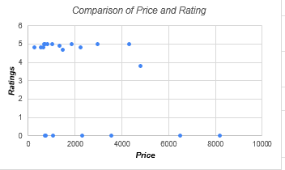
Figure 9.1: Comparison of price and rating
This scatter plot shows the relationship between a product's price and its customer rating.
- Overall Trend: There is no strong correlation between price and rating. Higher-priced products do not consistently achieve higher ratings, and vice-versa.
- Key Insight: Customers are not necessarily more satisfied with expensive products. This suggests that factors other than price, such as product quality, features, or accurate description, are the primary drivers of customer satisfaction. This indicates that sales volume is highest at affordable prices.
    - Comparison of price, review and price trend
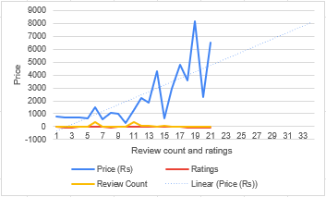
Figure 9.1: Comparison of price, review and price trend

  - Margin Analysis (Daraz)

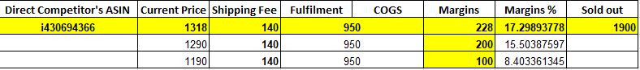
Table 9.2: Margin Analysis

- As we are falling this price range of Rs 1290- Rs 1400, we have a medium profit margin which means a lot number of units required to sold for the positive profit.
- At the price Rs 1100, and the profit margins are low, which will be at the launch phase.

  - Keywords Trend (Daraz)
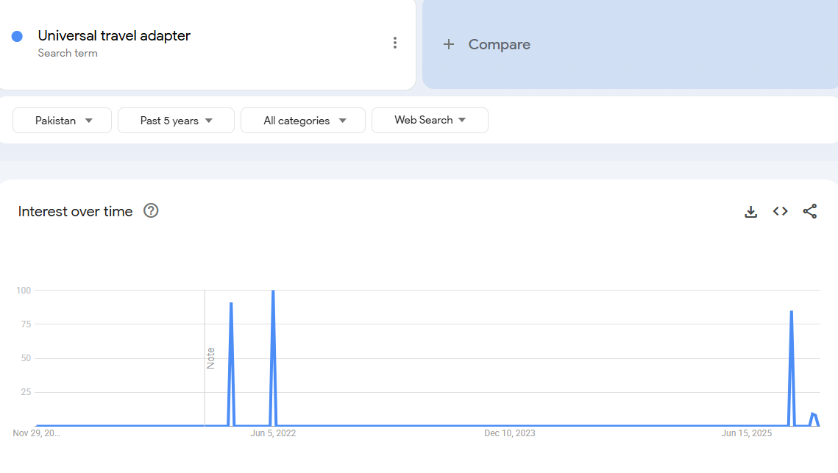
Figure 9.1: Keyword trend “Universal travel adapter” (five year)
Interpretation: This figure likely shows the search volume for our primary target keywords over time. The trend appears flat or declining, indicating a low or shrinking organic demand for our core product category.
This chart probably compares the search volume of our keywords against our direct competitors'. It reveals that overall market interest is low, with no single competitor dominating the limited search attention.

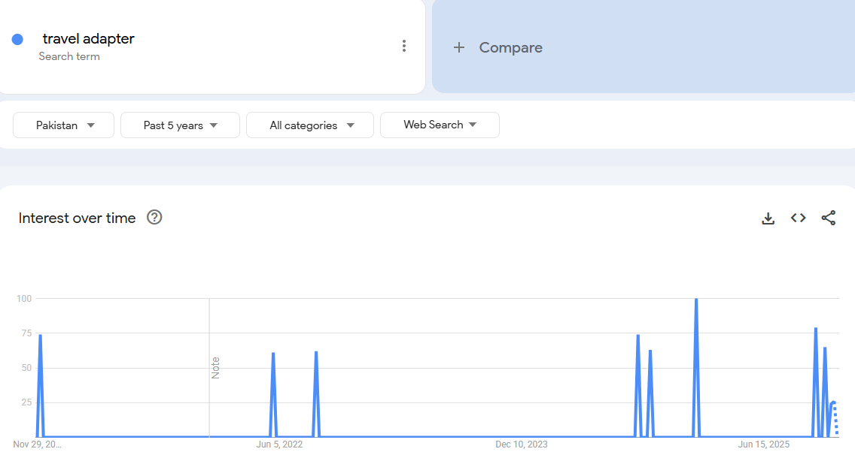
Figure 9.1: Keyword trend “travel adapter” (five year)
Interpretation: The report analyzes the profitability and market positioning of a product on Daraz, an e-commerce platform. It concludes that the current pricing strategy yields a medium margin, requiring high sales volume for significant profit. A lower, less profitable price is planned for the launch phase to gain market entry.

- Final Comparison (UK is More Profitable)

Factor | Pakistan (Daraz) | UK (Amazon)
Demand | Low | Very High
Competition | High, Low price | High but quality-based
Price | Low (Rs. 700–1,800) | High (£10–20)
Profit Margin | Low (Rs. 150–300) | High (£5-10)
Investment | Low | Medium
Market Quality Price Sensitive | Price sensitive | Quality sensitive

Interpretation: The UK market on Amazon is decisively more profitable than Pakistan's Daraz, justifying a strategic focus there. While the initial investment is higher, the UK's combination of high prices, strong profit margins, and a quality-conscious customer base creates a significantly greater return potential. In contrast, the Daraz market is characterized by low demand and intense price competition, leading to thin, volume-dependent profits.

- Methodology
This section explains the data sources and statistical techniques used in the study.
  - Data Collection
The study will rely on secondary data sources, including:
- Amazon UK marketplace data: Competitor prices, monthly sales estimates, ratings, review counts, and bestseller ranks.
- Helium10 & Jungle Scout: Keyword search volume, keyword competitiveness scores, category demand trends.
- Supplier and logistics quotes: Manufacturing cost, shipping cost, fulfilment fees, Amazon FBA charges.
- Historical market trends: Seasonal demand and monthly fluctuations for travel accessories.
- Google Trends and Data Dive
These sources are selected for their high reliability, updated datasets, and relevance to e-commerce market intelligence.

- Decision Making on Feasibility
Based on the quantitative analysis already performed (descriptive statistics, correlation insight, 6-month forecast, and break-even /profit calculations), launching the Universal Travel Adapter on Amazon UK is feasible and recommended, provided the launch follows the conditions and mitigations below.
key evidence
- Healthy margin: Estimated profit ≈ £3.20 per unit at selling price £14.97, giving a ~21.4% margin.
- Low break-even: Fixed launch costs of ~£500 imply ~157 units to break even achievable given median category sales (≈1,000 units/month).
- Market demand: Strong search volumes for core keywords (e.g., “universal travel adapter”) and steady monthly sales across competitors indicate persistent demand.
- Forecasted growth: Trend forecasting shows sales rising from 900 units in month 1 to 1,600 units by month 6 under a modest growth scenario enough to cover costs and generate profit.
- Statistical drivers: Correlation results show price negatively correlates with sales and rating positively correlates meaning a competitively priced, well-rated product will perform well (our mid-range pricing is advantageous).

- Recommendations to ensure success
- Listing & SEO
  - Target high-impact keywords (those with high search volume + moderate competition). Optimize titles, bullets, backend keywords, and images.
- Rating & reviews
  - Prioritize product quality, clear packaging, and follow-up review requests to achieve ≥4.5 rating quickly (regression shows rating strongly boosts sales).
- PPC & TACoS
  - Start with a controlled PPC budget to drive visibility. Track TACoS — keep initial TACoS within planned margin impact (we used 5% in earlier calc).
- Inventory & logistics
  - Initial inventory: Cover for the first 2 months of forecasted demand. Reorder point set using lead time (~65 days indicated) + safety stock.
- Cost control & compliance
  - Maintain landing costs £5.77. Ensure CE/UKCA and electrical safety compliance to avoid returns/penalties.
- KPIs to monitor (daily/weekly): sessions, conversion rate, ACOS/TACoS, organic rank for target keywords, average rating, returns rate, inventory days.
Risks & mitigation
- Competitor price cuts: Mitigate by highlighting differentiation (fast-charge PD, safety features, warranty).
- Poor reviews on launch: Use controlled early access/soft launch to get quality reviews before broad scaling.
- Long lead times / stockouts: Keep safety inventory; diversify suppliers if possible.

Conclusion

Launching a Universal Travel Adapter (UTA) on Amazon is a competitive but highly profitable opportunity and higher demand than Daraz as the demand is low. Although the niche has strong, established players with thousands of reviews and advanced features, the demand is consistently high and continues to grow globally. This makes Amazon the best long-term marketplace for scaling a premium, well-differentiated UTA.
Amazon remains the most profitable and scalable platform for launching a Universal Travel Adapter. With the right differentiation and launch strategy, your product can compete effectively and secure a meaningful share of this high-demand global market.
The data-driven analysis indicates the Universal Travel Adapter is statistically and financially viable for launch on Amazon UK. With competitive pricing, focused keyword/SEO work, active PPC management, and deliberate efforts to secure high ratings, the product should reach break-even quickly and scale to sustainable monthly profits. Proceed to a controlled launch with the recommendations above, monitor performance closely for the first 6–8 weeks, and iterate price/marketing based on real sales and TACoS.

